Design Thinking – UVA

Design Thinking for Innovation

Contents

Module 1 – What is design thinking? 2

Introduction to design thinking 2

What Is Design Thinking? Hear from the Experts 4

The Good Kitchen Story 4

Business Model Innovation 4

Challenges Best-Suited for Design Thinking 5

Visualization tool 6

Module 2 - Preparing Your Mind for Innovation 7

The Physics of Innovation 7

The Story of George & Geoff 9

How Prepared is your mind? 11

Storytelling Tool 13

Module 3 – Idea Generation 14

The idea generation process 14

The MeYouHealth Story Part I: What Is? 15

The MeYouHealth Story Part II: What If? 16

Mind Mapping Tool 16

Module 4 – Experimentation 19

What wows and what works 19

The IBM story 20

Learning Launch Tool 20

Reviewing our Lessons 24

Strategic Opportunities 26

# Module 1 – What is design thinking?

## Introduction to design thinking

“It's a term that is somewhat controversial. Particularly the thinking part. Since as you'll learn as we talk more about it, this approach to decision making is about a lot more than just thinking.

So what else is it about? Well, let's start with a popular view of the creative process. I call this view the Moses myth” (*the belief that only a special person can part the seas and create.*)

“In this view, the tangled mess morphs, into a **systematic series of questions**.

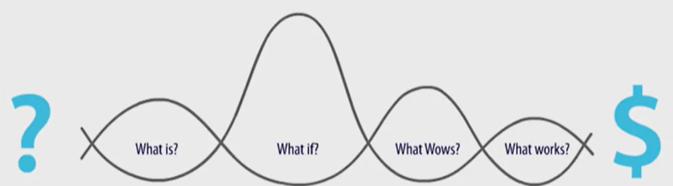

The first of these questions is, **what is**? And it explores current reality.

All successful innovation begins, I believe, with an accurate assessment of what is going on today”

“Attending to the present pays dividends in two crucial ways.

First, it helps broaden and perhaps even change completely our definition of the problem or opportunity we want to tackle. We can unwittingly throw away all kinds of opportunities for innovation before we even get started if we adopt too narrow or too conventional a definition of the problem.

Second, this attention to the present helps uncover unarticulated needs, which are the key to producing the kind of innovative design criteria that generate really differentiated solutions. And those are the kind that we want to build profitable businesses.

*‘What is’* saves us from having to rely entirely on our own imagination as we move into idea development. And it gives us solid and ideally deep insight into what our stakeholders truly want and need. Which reduces the risk of failure with a new idea.

Focusing on ‘*what is’* helps us to specify what a great solution will look like without telling us the solution itself.”

The second question is **What if**?

“So, we've examined the data we've gathered, we've identified patterns and insights and we've translated these into specific design criteria as part of the ‘*what is’* phase. Now we're going to use those criteria to ask ‘*what if*’? Keeping in mind that we want to start this part of the process by focusing on possibilities.

*What if* anything were possible?

That, I believe is one of the most powerful questions anyone can ask. So often we get trapped into starting with constraints rather than possibilities. And then the future ends up looking a lot like the present.

This phase is where brainstorming occurs. Brainstorming is a process that most managers have learned to hate. But this time I promise will be different. Rather than relying entirely on our imaginations and idea generation, we're going to go back and use the insights and the criteria we generated during data gathering and pose a series of trigger questions.”

(*I think what she is referring to the data gathering phase is simply the ‘What is’ phase from before*)

“And then in concept development we're going to take those individual ideas and combine them, just the way kids do with Lego's, into all kinds of different cool creations. And we'll call these creations our business concepts.”

**What Wows?**

“And now that we have a whole set of business concepts it's time to move to the first stage of testing by asking our third question. ‘*What wows’*?”

“Now if we get the first two questions approximately right we'll find to our simultaneous pleasure and dismay that we have far too many interesting concepts to move forward all at once. And so we have to make some hard choices.

As we whittle the field of concepts to a manageable number, we're looking for those that hit the sweet spot. The wow spot. Where the chance of significant upside for our stakeholders matches our organizational resources and capabilities and our ability to sustainably deliver the new offering. This is the **Wow Zone**.

And making this assessment involves surfacing and testing the assumptions about why each of our concepts is a good idea. The concepts that wow, the ones that pass the first test, are good candidates for turning into experiments to be conducted with actual users. In order to do this, we need to transform the concepts into something a potential customer can interact with, a prototype.”

**What Works?**

“So finally we're ready to learn from the real world by asking our fourth question. ‘*What works*’. And trying out a low fidelity prototype with actual users. If they like it and give us useful feedback, then we refine the prototype and test it with yet more users. Iterating our way until we feel confident about the value of our new idea and are ready to scale it. As we move through what works. It's important to keep in mind some of the principles behind this learning in action stage.

Work and fast feedback cycles. Minimize the cost of conducting experiments. Fail early to succeed sooner and test for key tradeoffs and assumptions early on.”

“And so, this is what I'm going to be focusing on in our time together. Design thinking as a problem solving approach that asks four questions, and that is human-centered, possibility-driven, option-focused, and iterative in its approach. Let me talk about each of those for a moment in turn. Human-centered is where we always start, with people. With real human beings. Not demographics or segmentation schemes. Design thinking emphasizes the importance of deep exploration into the lives and the problems of the people we hope to generate value for before we're allowed to start generating solutions.

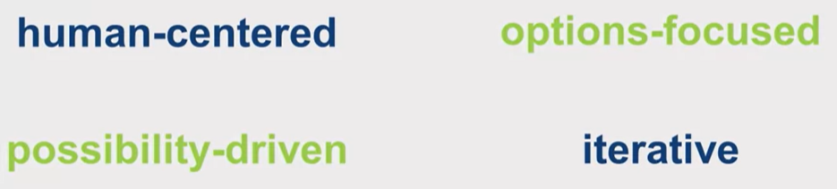

This is why it's often called user-driven design.”

“Design thinking is also possibility-driven. It uses this information we've learned to ask the question, what if anything, were possible? As we begin to create new ideas about how to serve the­m.”

## What Is Design Thinking? Hear from the Experts

2 different types of problems. There are mysteries and puzzles

Convergent and divergent thinking

Interviewees keep saying stuff that it is the other half of analytics (which has been more developed so far)

“I am actually fairly bullish about those, the stain power of design thinking. I really I am. only because if you follow the trajectory of just the discussion of business and design, it isn't like one of those management fads where you can kind of see it fading away, where fewer people are talking about it. You see that it has this pretty steady trajectory, and I don't think that it's risen too quickly. A lot of times you have a business, management fad that, that has a kind of super nova trajectory where it explodes and everybody is talking about it and then it disappears. Whereas, I think design thinking has had a slower, steadier trajectory and I think that more people truly are understanding it.”

## The Good Kitchen Story

*They go over how an innovation firm used design thinking to help fix elderly nutrition in Denmark*

## Business Model Innovation

“Business model innovation is, it's, it's kind of the Holy Grail of the innovation space, because most studies will prove that when you change your business model in a positive way, that ultimately gives you the greatest bump in profitability and the greatest overall success.”

“One of the things that we, we teach in design school is less about a value chain and more about the idea of an ecosystem.”

“The old joke is that a lawyer will not ask you a question that he or she does not already know the answer to. It's just the opposite for designers. We only ask questions where really, we have no idea. You know, where, we want to be like sponges, and just sort of collect from the people that we're working with. It all goes back to one of the core approaches that we have, which is the **ethnographic interview**. ethnographic interviews are very different than the typical business interview. The ethnographic approach is one where we only ask open-ended questions. And those questions, we don't know the answer to, and we let the actual individual interviewee lead the conversation.”

## Challenges Best-Suited for Design Thinking

“Design thinking is not a kind of one size fits all solution. Design thinking works best on particular kinds of problems. How do I identify the kinds of problems that design thinking is really suited for versus those that our traditional analytic tool kit is better suited for? Well, earlier Jeremy talked about the differences between mysteries and puzzles as one way to understand the difference between the kinds of problems design-thinking solves. Relative to the more ordered even if more complex problems that traditional analytics work well for.”

“Another way that designers have talked about this distinction between different types of problems and which I have always found particularly helpful is the difference between problems that are wicked versus problems that are tame.

With tame problems we start with good agreement about the definition of what the problem is. We often have fairly relevant data and we can determine cause and effect. And so we can successfully use linear processes and existing data to come up with an answer.

None of these conditions apply to wicked problems.

In wicked problems, the stakeholders involved can't even agree on a definition of what the problem is, much less agree on a solution.

There may be a lot of data, but it's not clear whether any of it is relevant or how, and the situation is often sufficiently complex and fluid, so that we can't really confidently predict cause and effect. And the only way to see if something works is to try it.”

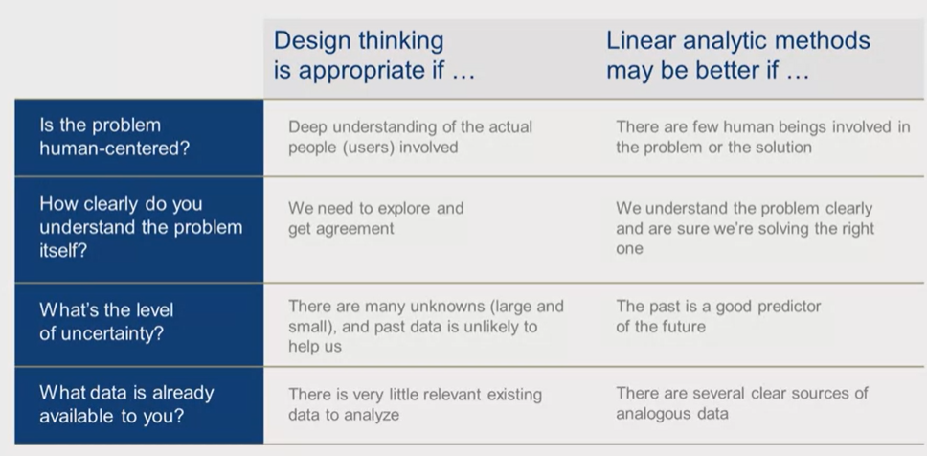

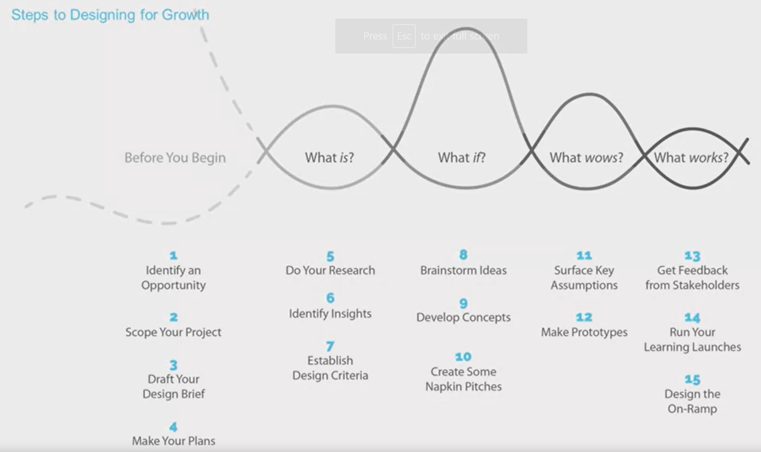

“In our upcoming sessions, we will explore a 15 step model that will walk you through the four questions and help you think about the kinds of design tools best suited to each stage. We've talked today about what the first few of these important steps looked like. Steps like identifying the right kinds of problems for design thinking. And steps like then scoping the problems correctly and keep in mind how the good kitchen started out with too narrow a definition, and fix the menu.”

## Visualization tool

“Visualization isn't really about drawing. It's actually about visual thinking, and we all do it. What I've seen is that through practice, you can actually get better and better at doing it. Visualization is anything from the things we write on a chalkboard or a whiteboard. To the images that we create in a PowerPoint presentation, to photography, video. It's basically anything that takes us beyond just using words or language alone. Things like color. Things like symbols for example.”

“The primary tools for, for thinking visually are really just mastering some basic elements of imagining people, spaces, situations and actions or movements. It's very easy to create a simple diagram, and most anyone can draw a stick figure, an arrow, a circle, a square.

# Module 2 - Preparing Your Mind for Innovation

## The Physics of Innovation

*Storytelling is key*

*Innovation starts inside*

*Insights from “ordinary” managers at big and established firms:*

“We interviewed these managers in-depth, focusing on the practices and behaviors that they had used, to succeed. And we discovered that the growth they achieved, wasn't necessarily the result of some farsighted corporate strategy, or the invention of a radical new product or technology. More often than not, successful and sustainable growth was ignited, by the actions of these managers themselves. The kind of almost chemical reaction that these leaders generated, lead us to call them, The Catalysts and we named the book on our findings, after them. Often, acting without substantial capital investments or corporate support, these extraordinary catalysts were masters, at leveraging existing resources, to spark growth. In the process of studying the catalysts, we learned something else though, that really surprised us. Most of these managers, it turned out, were succeeding in spite of their organizations, not because of them.”

“After years of studying innovation and working with managers at all levels, trying to achieve it, we have come to believe, that innovation is in fact, governed by its own natural laws.

An underlying reality, that sets the context for innovation, in much the same way that Einstein's Law of Relativity, accounts for the movement of objects, in the space time continuum. The most fundamental natural law of innovation, is that the only certainty is uncertainty.”

“Even the best managed and perhaps maybe, especially the best managed, large organizations are beautifully designed, to produce standardized, low variance results, through careful execution in an environment of predictability. They employ talented leaders at all levels, who have learned to focus on efficiency and control. Because of this, they excel at execution, and at driving waste and variation out of the system, and they have a state of the art tool kit for accomplishing this. But unfortunately, the pursuit of innovation is inherently, messy and inefficient.”

“Unlike execution, exploration is a high variance activity. And if, as work in the area of total quality management would suggest, variation is the mother or waste. Well, it's also the mother of invention.”

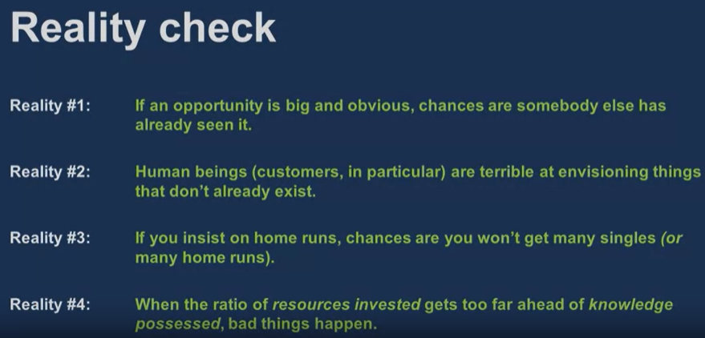

“And so, when they're challenged by their organizations' professional doubters, to prove, using today's data, that their theories about, some not yet existing business makes sense, managers find it hard to present a winning case. And as a result, they get trapped in what we call, growth gridlock.”

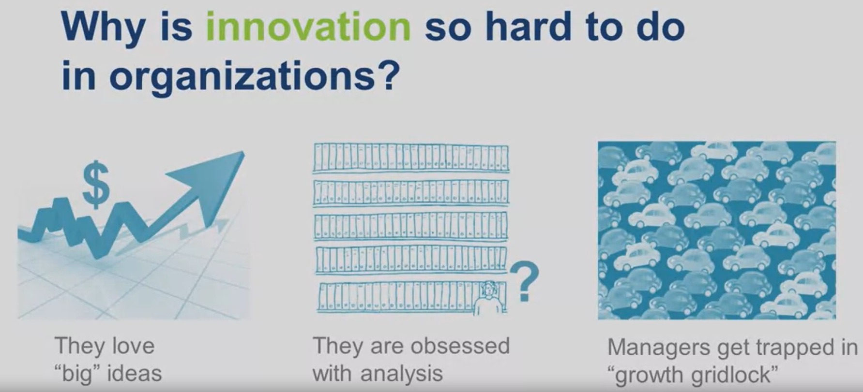

What does a prepared mind look like??

They go over that we usually prefer one side of the brain than the other but we should understand how to use the whole brain. This is how:

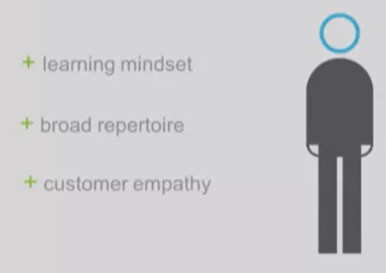

**Learning mindset**: Being ok with failing

**Broad repertoire**: “If however, people work in a variety of functions and businesses as their careers developed, they can quickly and skillfully, learn to play a lot of different pieces. A broad repertoire can be an important enabler of innovation.”

**Empathy**: Empathy is much more than customer focus

“un-articulated needs is notoriously difficult. They don't show up in the text of market research reports, based on surveys and focus groups.

The successful techniques in use here, are almost always ethnographic and involve close observation, of what customers are trying to accomplish, not necessarily what they say they want.

## The Story of George & Geoff

George is the traditional successful manager at a large corporation. This is how his experience in handling an existing business could be vs the experience handling a request to take over a struggling business or with innovation:

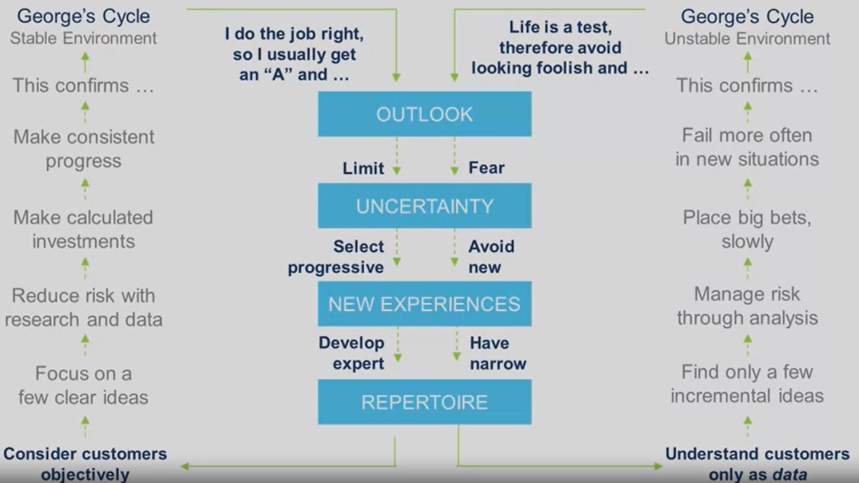

“When our research team met Geoff, he had just joined Pfizer Consumer Products with a strong mandate to grow that business organically. He arrived there from Doblin, an innovation consulting firm, bringing with him years of experience in different businesses and in different functions. Including, change management practice at Arthur Anderson and two marketing ventures he'd started up. While George worries about looking foolish and fears uncertainty, Geoff evidences what Stanford psychologist Carol Dweck calls a **growth mindset**. This is the conviction that the world, including one's own abilities, can be shaped and changed.”

“In Dwecks's view, our early classroom experiences encourage one mindset or the other. And usually the fixed wins, she argues. But the difference is, these mindset set in motion are profound. They establish dynamics with lifelong consequences for our ability to identify and lead innovation. Dweck's mindset argument is supported by the research of other psychologists, such as Columbia professor Tory Higgins.

In his research on motivation, Higgins notes that virtually all theories of motivation, from the time of the ancient Greek philosophers through Sigmund Freud to today. Are based on the idea that we approach things that are pleasurable and we avoid things that are painful.

What's less understood, he argues, are the strategies individuals use to operationalize these principles. He calls these our regulatory focus, after the role they play in regulating our choices.

Like Dweck, he sees two primary types of focus, promotion and prevention.

People with a promotion focus are motivated by some kind of new and exciting end state. Which leads to a concern with advancement, growth and accomplishment.

Those with a prevention focus, like George, are motivated more by avoiding negative outcomes, and so are concerned with protection and safety.

Promoters like Geoff prefer errors of commission because their inclination is to act, to pursue multiple avenues to reach this goal.

Preventers like George prefer errors of omission. Choosing instead not to even act in order to minimize the possibility of a negative outcome.

These early differences in mindset and focus set the stage for the choices we make.

Geoff's tend to lead to success when the focus is on innovation. George's, although it has helped him succeed in a stable environment, often increases the likelihood of failure when the focus is innovation. Because George fears uncertainty, he avoids new experiences, whereas Geoff seeks them out.”

“It's important to note that what we call George's narrow repertoire, we used to call deep expertise in a stable world, where it was an asset.”

“The number one reason growth ideas fail is that we misjudge what customers want. So the surest way to reduce the risk in any innovation is to develop a deeper feel for that”

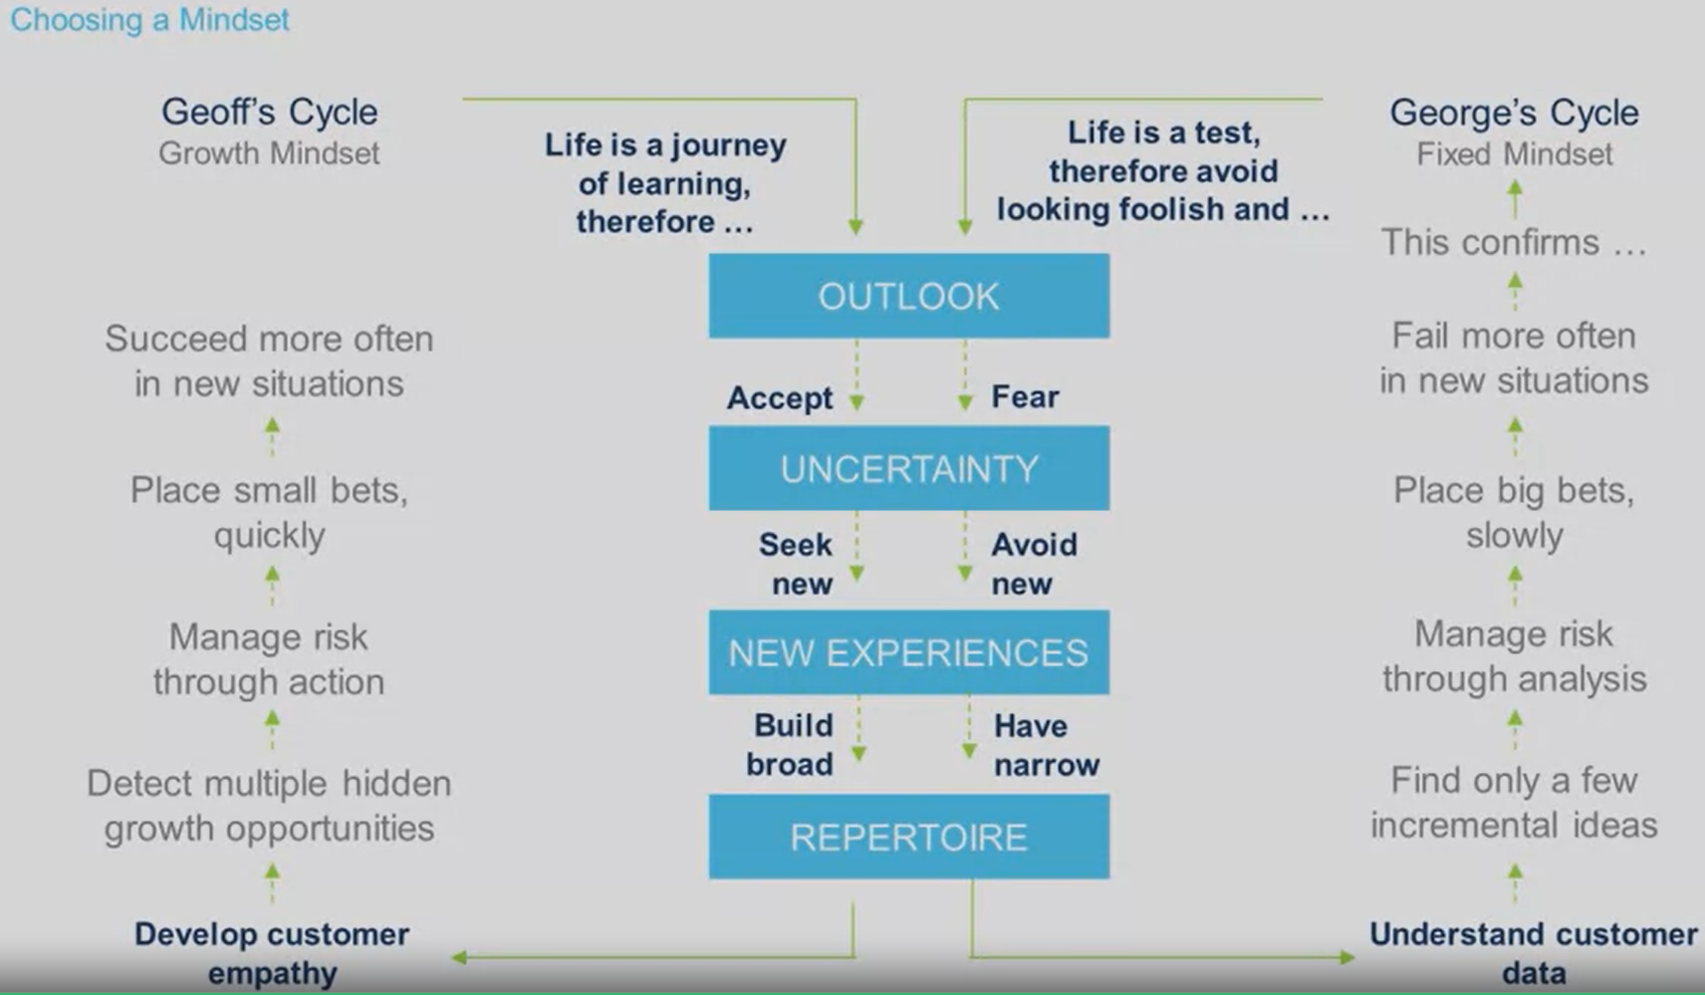

How to help George:

“But, let's not forget about George. How do we help George to succeed?

Not by asking him to become Geoff. That's not who he is. But by showing him how, when the situation calls for it and involves uncertainty, he can adopt more of Geoff's behaviors.

But first, we have to help him overcome his fear of uncertainty and the anxiety he feels. Otherwise, he won't even see the disconfirming data that his experiments produce. We know from neuroscience that when we are anxious our brain tries to help us out. Unfortunately, it does this by keeping us from even seeing information that disturbs us. Now, I suspect this is how most of us survived our children's teenage years. But if innovation requires that we learn how to fail fast and cheap, this brain trick spells disasters. And this is where design thinking comes in.”

## How Prepared is your mind?

Come back to this video, sounds like good advice on what steps to take

There are more resources about this in the course

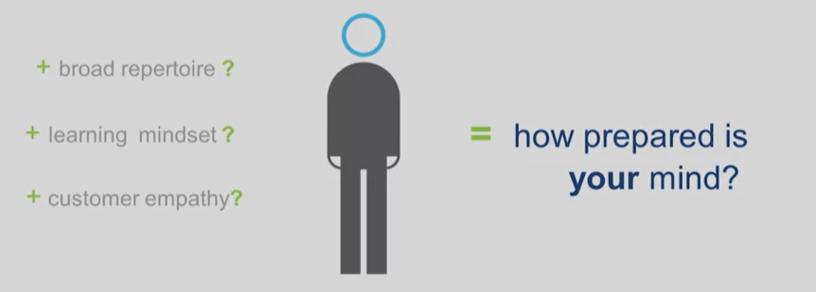

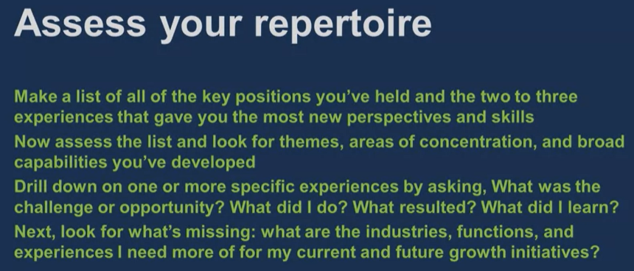

1. I'd like you to make a list of all the key positions you've held. For each one, include the organization, the functional area and the two or three experiences that gave you the most new perspective and skills.
2. Assess that list and look for themes, areas of concentration and broad capabilities you've developed. Drill down on one or more of those experiences by asking, what was the challenge or opportunity? What were my options? What did I do. What were the results? And, most importantly, what did I learn?
3. look for what's missing. What are the industries or functions or experiences I need to get more of for my current and future leadership development.

If you're really committed, you're going to have to step out of your comfort zone. Here's some suggestions for how to do that: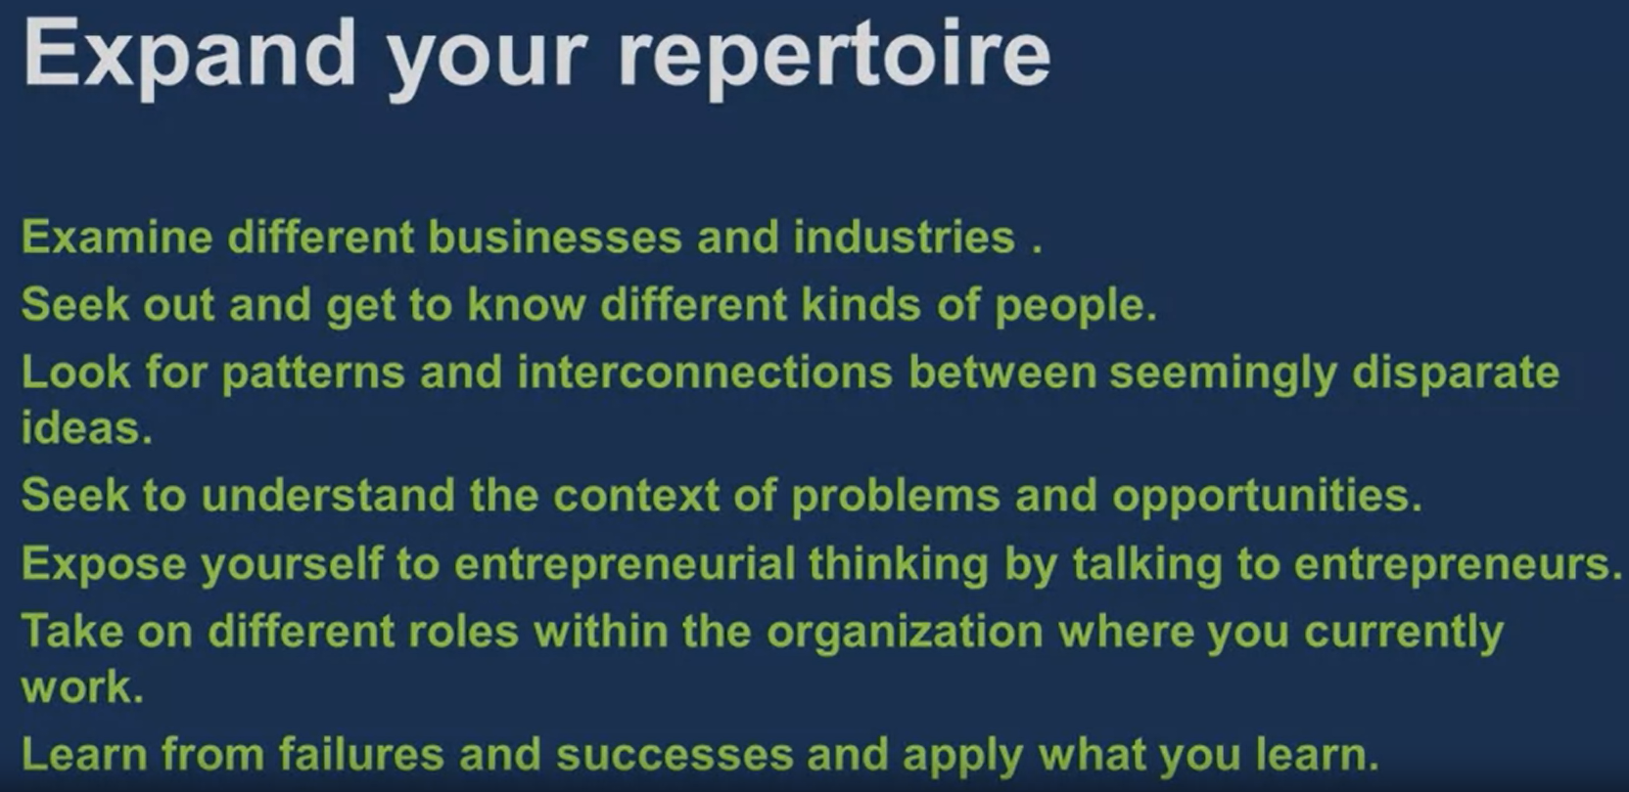

Now assessing my mindset:

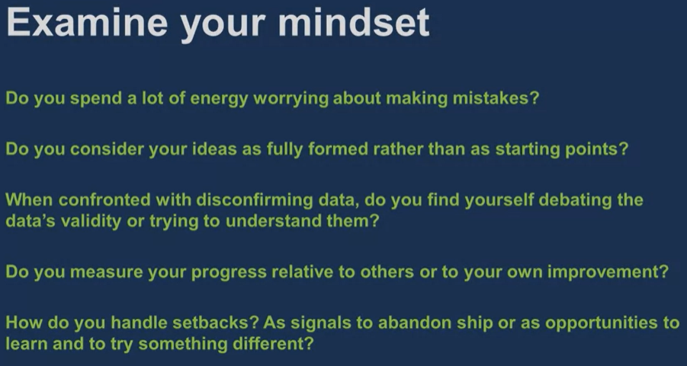

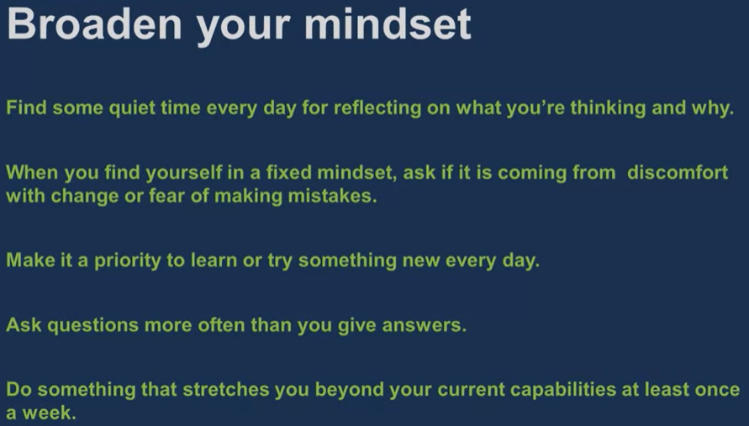

Imagine what success looks like and fee;ls like on a regular basis, even when, maybe especially when, it seems like it's outside of your reach.

## Storytelling Tool

This is an interview

“Storytelling is the difference between solving a problem and creating a cause.”

“Strategy's accessible, accessible only for about three groups of people. Right? The leaders that write it, the consultants that help them do it, and the professors that create case studies around it. For everyone else, strategy is a difficult thing that causes complexity and uncertainty in our lives. And I think what storytelling does for leaders in terms of strategy, is it makes it simple. It makes it relate-able, It gives strategy color, and life In character and plot.”

# Module 3 – Idea Generation

## The idea generation process

Today we are focusing on steps 5-10 :

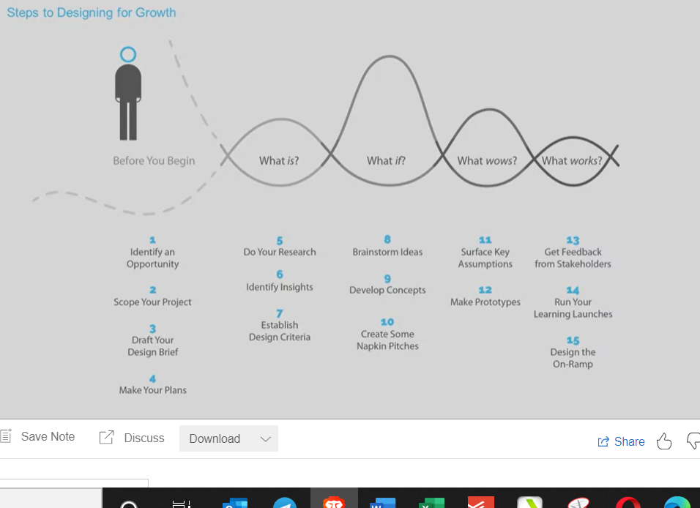

“Previously, we would have selected an opportunity that we believe the design thinking methodology is well suited for. And made sure that the scope of our focus wasn't too narrow. Because we don't want to define the problem in a way that eliminates innovation opportunities at the outset.

In our final step in preparation, we would have laid out a design brief that summarized our project and specified who our target was, the kind of outcomes we wanted to achieve and how we would measure success.

We would then have converted our intentions into a research plan that specified. Who we would study, where we would find them, and what questions we might ask them, as well as the timeline we wanted to work within.

And all of these resources will be available to you on 'Design at Darden." So now we're ready to begin asking the question, what is?”

“We will capture our new ideas in the form of a napkin pitch, which is exactly what it sounds like. It's a quick, high level summary of an idea that you could fit on a napkin if you needed to. And remember, that we want a portfolio of napkin pitches, and not just one.”

## The MeYouHealth Story Part I: What Is?

*20 in depth interviews is usually enough.*

“The purpose of research in the ‘*what is*’ stage, is not to prove that an idea is good. Let me repeat that. It's not to prove that an idea is good. It's to inspire us to have better, more innovative ideas. And even one interview, if it's a really good one, can accomplish that inspiration. The proving piece in the design thinking methodology happens later. It happens when we ask the question what wows? And then what works? Those are topics we'll turn to next week.”

“These approaches are called projective because, like a Rorschach, they use ambiguous stimuli to get us to project and arrive at deeper thoughts.”

*They go over some visual tools that can be used in an interview for example this matrix:*

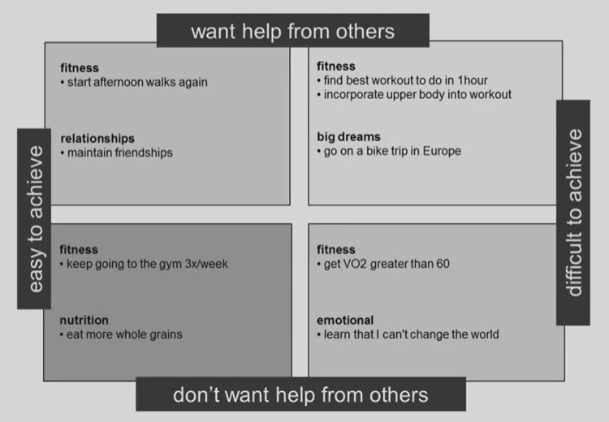

Mind mapping tool:

“As they looked for themes and patterns, the teams started to see systematic differences in the knowledge, attitude, and skills of the different interviewees. These insights led to the creation of seven personas.”

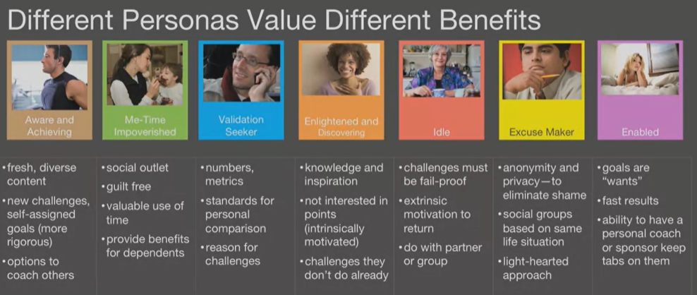

It is useful to create personas (it doesn’t necessarily have to be the ones above)

“The Essential team took all of these insights and used them to create criteria for the qualities of the solution that would help the seven different personas. They used a set of tools for brainstorming as part of asking, ‘*what if*’, that you will want to learn more about. These are not the traditional approaches to brainstorming that many managers love to hate, the think of ten novel uses for a paperclip kind. These are structured techniques aimed at collaborative idea generation. They use trigger questions, and multiple rounds of silent idea writing, and then sharing to allow us to create sessions that are both data driven and collaborative. And sessions that are not dominated by the loudest voice or by the HPO, the highest paid opinion in the room.”

## The MeYouHealth Story Part II: What If?

If we look at the metric of return engagement, the percentage of people who've used the product for a length of time who still continue to use it, their research found that about 2 3rds of Daily Challenge users were still active after 90 days. Most websites are pleased with 20 to 30% engagement at 30 days. After 1 year, 34% of users were still using the product. Much higher than rates for other wellness products.”

*Summary of what MeYouHealth did (what we have gone over previously)*

“Let's go back to our diagram and see what we've learned from MeYou Health.

We met Chris Carter, an entrepreneur with a growth mindset, who saw what he believed to be a big opportunity. How to use social networking to help us build healthier lives. He enlisted designers from Essential to work with him, to ask what is a big hairy question in this case. They used a variety of ethnographic techniques, many of them projective. Like journal writing and creating collages, to help them uncover deep needs. (This was asking the interviewees to create a drawing or a journal of their experience)

They used mind mapping to help them look for themes and patterns (This was the matrix). And they then created personas to capture the differences across the individuals, and brainstormed to find solutions. Whether it was for the me time impoverished, the excuse makers, or the validation seekers.

They found ways to help them lead healthier lives, in ways that seem small, but can add up, it turns out, to be really big. And they did this by asking, ‘*what is’*, focusing on the present to uncover hidden attitudes and needs.

They then used those insights to ask, ‘*what if*’? And out of that process, created a whole host of new and innovative solutions.”

## Mind Mapping Tool

“Mind mapping is one of the most powerful tools in the design thinker's toolbox. It's used to look for patterns, it's used to look for insights, that lead to more creative solutions to your design challenge. In the first phase of design thinking process, we take a look at the current reality. At ’*what is*’. In doing so, we amass a huge amount of data. Before moving to the next phase, ‘*what if*’, we need to distill all that data into information and insights that can be easily communicated. This is just what mind mapping does well.”

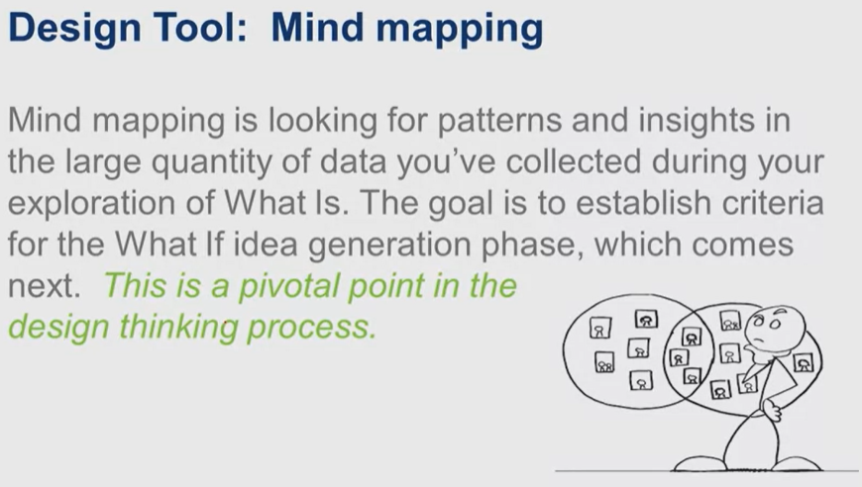

“Mind mapping provides a segway from ‘*what is’* to ‘*what if’*. Mind mapping is an engaging alternative to that giant report we might otherwise have written to sum up and communicate in prose and charts and spreadsheets.

let's be clear what we don't mean by mind-mapping and the design-thinking process. You're probably familiar with a mind map. You're probably familiar with one that looks something like this:

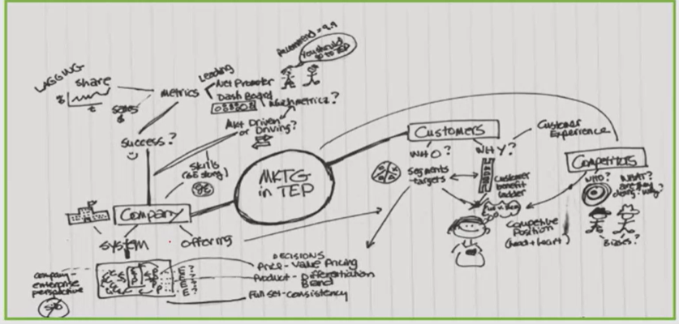

“In their book, Designing for Growth, Jeanne Liedtka and Tim Ogilvie set out the mind mapping process step, by step. They used the metaphor of a yard sale or an art gallery for the initial steps. The idea being that you have a lot of stuff, and you want to present it to other people.”

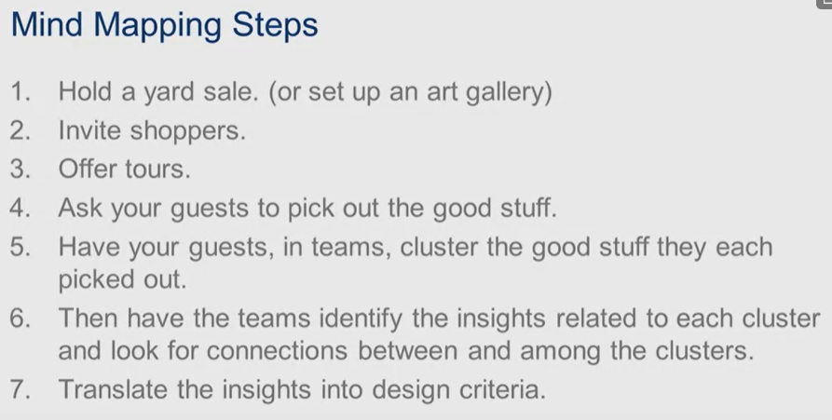

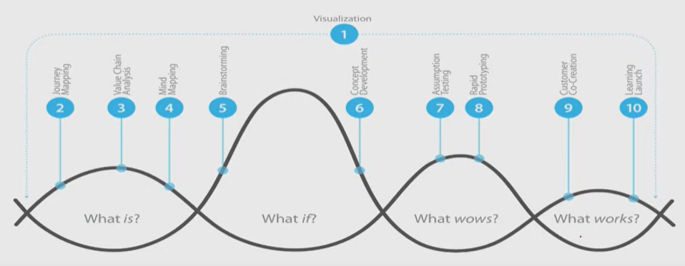

\*\**Come back to this video they kind of rushed through how to do it*\*\*

# Module 4 – Experimentation

## What wows and what works

*We are going through steps 11-15*

This starts with a portfolio of napkin pitches that we had talked about before

We are going to go through the case of an established firm (IBM)

The WOW zone:

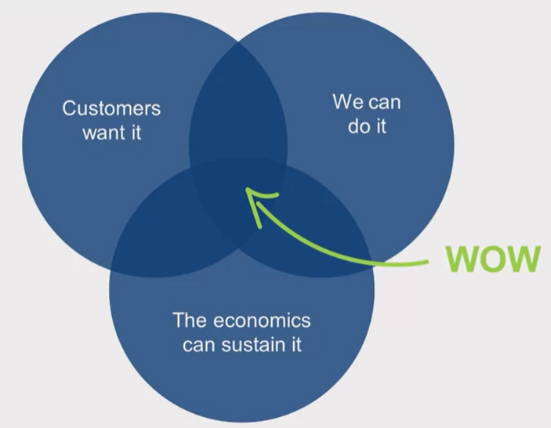

“This process is pretty straightforward. It starts when we immerse ourself in the data which we've already done during the ‘*what is*’ stage. Then in ‘*what if*’, we generate ideas. Now we're at the stage in ‘*what wows*’ where we're going to surface the assumptions underlying why our ideas are good. And we're going to conduct a small experiment. The results of that experiment will tell us what comes next. If our assumptions prove to be true, then congratulations, you've got a winning and tested idea and you're ready to scale it. If our assumptions are disproven though, we've got to think.

Is the assumption that was disproven so fundamental that the idea really has lost it's value, in which case were going to table it. Notice I said table, not kill, because the idea that doesn't make it today maybe one of tomorrow's biggest winners. And we really want to keep an inventory of ideas ready to implement as situations change. Sometimes though, when our assumptions are disproven, we're able to iterate, revise our idea, so that we can accommodate the new learning we've had, and then we go back into the loop of idea generation.”

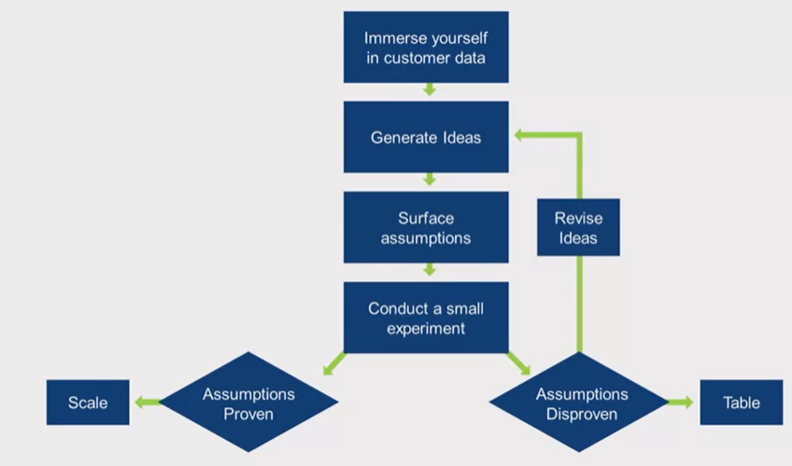

## The IBM story

*We are looking at the WOW zone here and how they validated in real life*

IBM attends a ton of trade shows so they were looking for a way to:

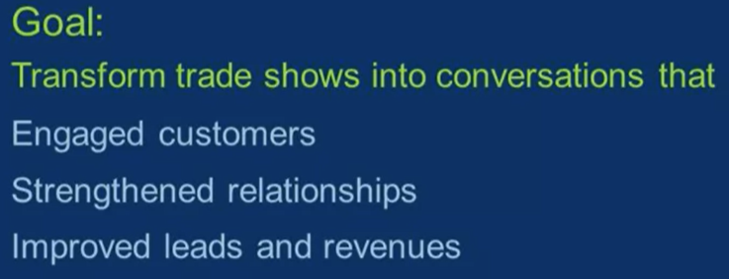

“IBM had another business objective as well. They wanted to create experiences that embodied the principles and elements of a new strategy of theirs called Smarter Planet. IBM Smarter Planet positioning was born out of a recognition that the world was becoming more dynamic and complex, and that technology was playing a larger role in addressing global pressure points across industries, and that IBM could help to solve these problems through technology. For IBM, Smarter Planet is not just a campaign or a slogan, but a way of looking at the world. It's a call to action to use systems thinking and technology to address the world's biggest problems using IBM's technology and business practices. Accordingly, IBM wanted to create experiences that embody these principles and elements of smarter planning.”

*IBM increased lead generationg by 78%*

“I'd like to ask you to think about a small experiment that you could do to test the attractiveness of a new idea you have. What would that look like?

## Learning Launch Tool

*He is going to go over what to do with the ideas we come up with*

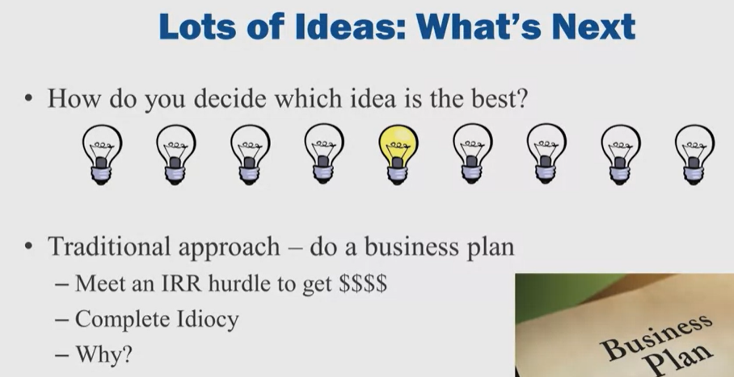

*Thinks Business plan approach is a waste of time. Based on too many assumptions and having to tweak them too much as reality hits*

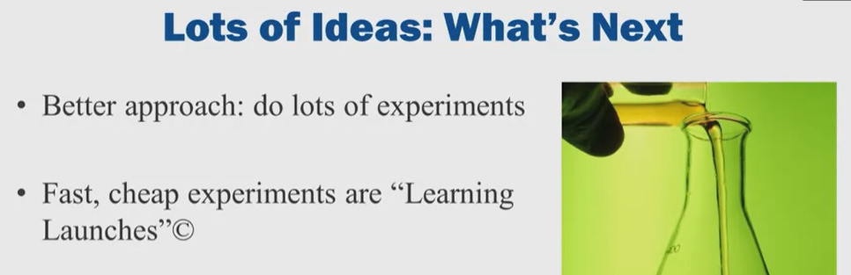

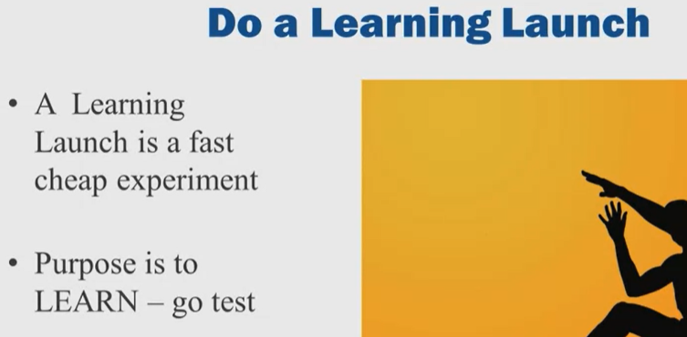

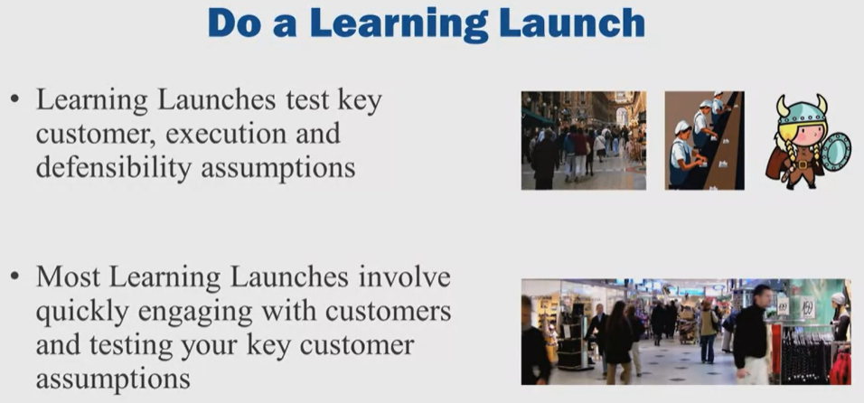

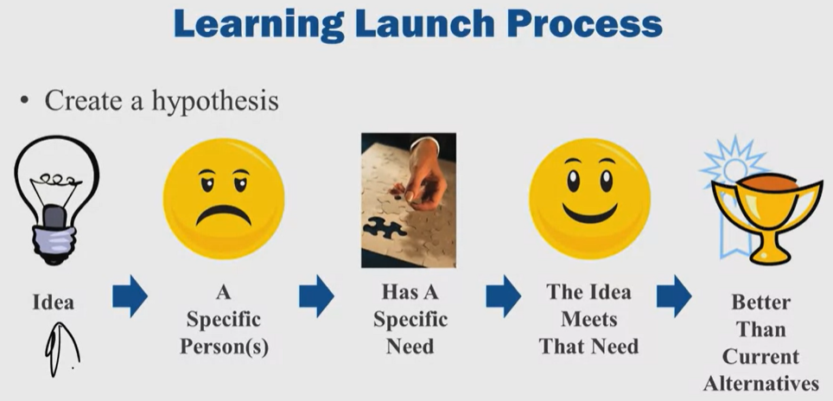

“You don't have to be a scientist. It's easy to create a hypothesis. You've got an idea, so the idea has got to relate to a specific group of customers.

Whether it's a person or group of persons, you hope there's lots of customers that have this specific problem. So you have a specific group of customers, and see that frown? They got a pain, a customer pain that your going to try and solve. They've got that specific need that's causing the pain, and you've got an idea that meets that need or solves that need better than the competition. That's what you think. So the hypothesis is, Jims and Janes have a specific need, they want to be able to do this. My idea meets that need better than the current alternatives because, whatever fill in the blank is. That allows you to start unpacking, peeling an onion. What I call peeling the artichoke and getting to the heart of what's that burning need.

What must be true for your idea to be a good one? Because see, an experimental learning launch is a search for the truth. The purpose of a learning launch is not to prove you're smart. The purpose of a learning launch is not to prove you've got a good idea. The purpose of a learning launch is to get the truth and then the truth either confirms or dis-confirms your assumptions. See the truth is so important because in most cases the truth saves you money. Saves you time, cause in most cases, you can adapt or amend your idea. So that you can solve the truth, so what must be true and I call those, must be trues, or there's assumptions. What must be true for me to have this urgent need to solve this problem?

Then, I've got to go get data. Data, I'm looking for data, I'm not looking for opinions, I'm not looking for someone's unfounded guess. And the problem is you got an idea. And you know who thinks that's a great idea, you. You are a problem, you are a risk to be managed. Because, you have what we call confirmation bias. You will, subconsciously look for data that confirms your idea.

You think about, okay, why will the idea, under what circumstances will the idea be a bad idea? Under what circumstances will the idea, the product, the service not sell? Why will someone not buy? And you make a list of this, of disconfirming facts and you go out, yes you do, and you ask questions to illicit. Whether those disconfirming facts are out there, okay? You search for them either in conversation or by observing. You learned from professor Litka that observation is a key way to learn.

If you ask someone, Bob, do you think Jane has this problem? That's not good data. What should you do? Jane, what is your key problem? You don't ask Jane if she has that problem. What is your key problem?

“If the assumptions you go out and you do your learning launch, and you gather facts. If they're more likely to be true, notice I said that, more likely, cause you don't have enough data to know if it's true or not. In fact, you'll never know if it's true. If it's more, notice I didn't say highly, more likely to be true, you move onto the second phase of a learning launch. If they're not likely to be true, you have two choices, okay? You come to that fork in the road and you take it. Very famous academic said that, Yogi Berra. Alright, I'm making a joke, he's a, was a catcher for the New York Yankees. You pivot, which means you change your idea, you amend it and keep going. Or you put the idea in a trash can, while it's not a real trash can, it's a make believe because you put it on the shelf, because years later it may be valuable.”

“innovation is a probability game, best practices use entrepreneurial learn as you go processes. Make failure cheap and personally cheap.”

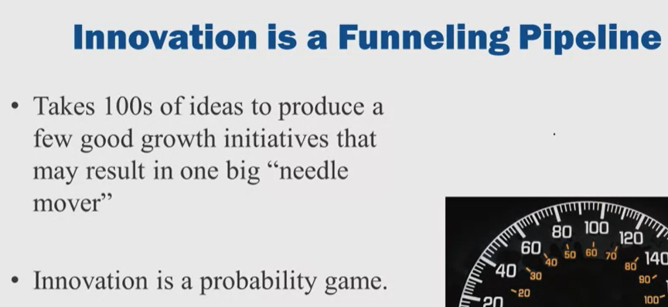

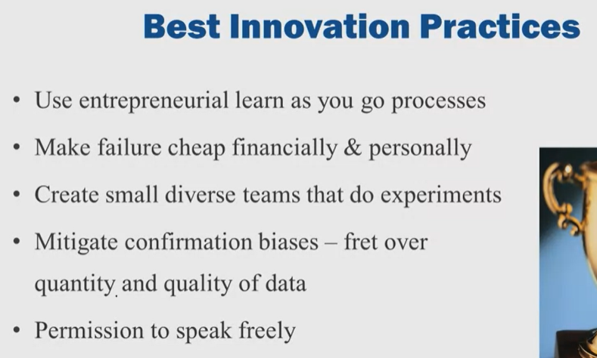

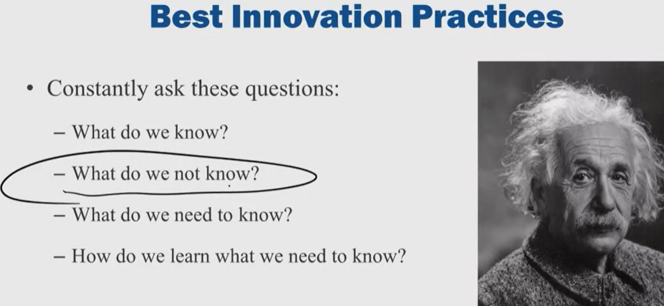

Here's the process, put your idea into hypothesis, figure out your key assumptions. Customer, execution. This is customer. Execution, defensibility, and I didn't talk about scalability because I always do that at the last of the test. Prioritize your key assumptions. Design the test, like we talked about. Do the test, confirming data you continue development. Disconfirming, you pivot or you put it on the shelf.

Each key assumption you figure out, who's the responsible person, who's on the team. How are you going to go figure out that fact whether it exists or not? How long's it going to take and what it's going to cost? Most learning launches can be quickly and cheaply.

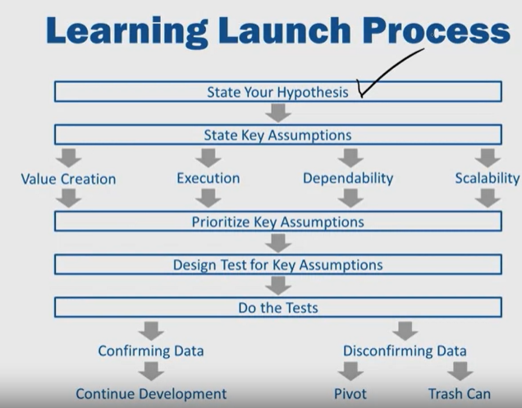

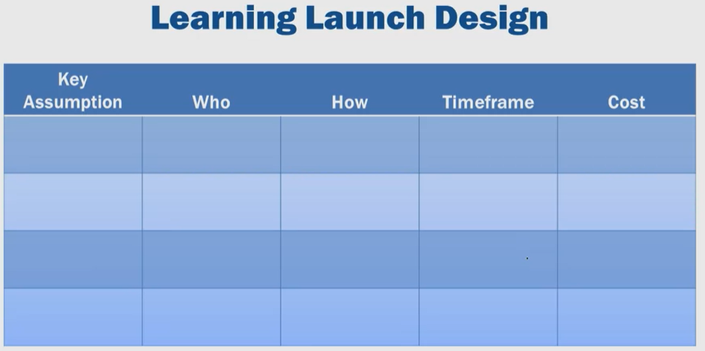

## Reviewing our Lessons

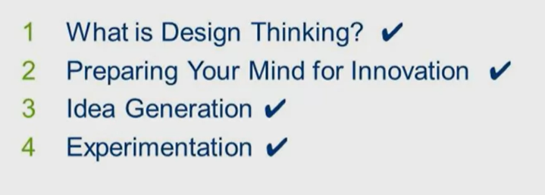

*Pasting the entire transcript here because it is a good summary:*

“We started with an overview and definition of the design thinking process. We looked at four questions, what is, what if, what wows, and what works that allow us to generate and experiment with ideas. And we talked about the specific kinds of problems that design thinking is well suited to. In that first session, we illustrated the design thinking in action, by telling the story of one organization, The Good Kitchen, and how they addressed the problem of poor nutrition in the elderly through the redesign of a meal delivery service.

They used a design thinking approach that allowed them to ask a better question, develop a deeper understanding of stakeholder needs, involve a broad group of stakeholders in co-creating new solutions, and then test these to make sure they were getting them right.

But design thinking, we argued, is about more than just process and tools. And in session two, we stepped away from the process to look at the role of the designer and his or her mindset. Maybe you remember the story of George and Geoff. We looked at how a mindset that avoided mistakes and focused on using objective data and analysis had helped George to succeed in a stable environment, but it was leading him towards failure in an unstable one. We contrasted this with the experience of Geoff, whose mindset focused on learning, understanding people as humans, and conducting small experiments instead of doing analysis that prepared him to see and act on opportunities much more successfully than Geoff in an unstable environment. Then, in session three, we returned to process and focused on idea generation as an activity, and we looked in depth at the first two questions, what is, and what if. We met Chris Carter, an entrepreneur who saw an area of opportunity he wanted to explore using social networking to help people adopt healthier lifestyles.

We looked at how Chris and the team at Essential Design used interviewing, journaling, and creative projection techniques to get inside the heads of people, helping them to create a set of personas that allowed them to generate a host of creative ideas that met the different needs of the different stakeholders.

And then we move from idea generation to testing, and explored the last two questions, what wows, and what works.

Through the story of IBM's partnership with GPJ to redesign their trade show experience, we looked at how their front end research into human interaction and learning translated into a series of prototypes that came together in a learning launch conducted at the Sibos trade show in Amsterdam.

And so we've looked at a variety of different organizations, very different. A local municipality, a startup, and a major corporation, each of whom use design thinking to solve very different kinds of problems. And, you know what? There was not a sign of needing Moses and his miracles at any point.

What makes these stories so inspiring to me, is not the presence of miracle making, but in fact, it's absence. The outcomes that our design thinkers produce may have been unexpected, maybe even some of them magical. But, the way they produced them was not.

In each case we can follow the process they took and the tools they used to get there. No parting of the waters or miracles of any kind required, just some disciplined bridge building.

So, as we followed this process through our three stories, it may have looked easy, but I guarantee you it was not.”

## Strategic Opportunities

“So where do our conversations over these past four weeks leave us? I think with a very clear set of opportunities. And I'd like to talk about how we can take advantage of those opportunities at a strategic level now.

For me, the first thing to recognize is the importance of staying in the question.”

“The second opportunity I'd like to talk about is to search for higher ground, not common ground.”

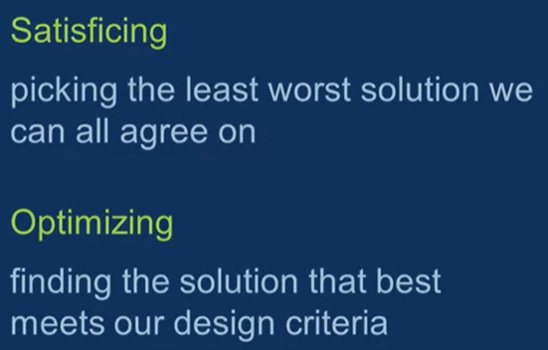

Design thinking succeeds in part because it refuses to get caught up in debates and either or thinking. Instead, it insists that we develop shared insights and ambitions before trying to generate ideas. And that we use data from experiments, rather than debates in conference rooms to determine the most effective course of action.

Let me talk about a third opportunity, I think that design thinking represents. It's less discussed, but it's important. And it's the contribution of design thinking to help us curate. To drill down to the essence of an issue and see what really matters. This is an increasingly important role in today's business environment. In fact curation has become a new buzz word. But what is it really mean behind that buzz word, to curate? Well, I like to think of it in terms of what a museum curator actually does.

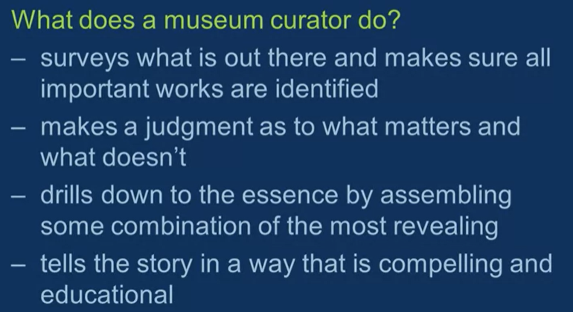

Another opportunity. And I think it comes from putting all of these other things we've talked about together. When you put the factors that we've talked about, aligning us around a common definition of the problem and the criteria of a great solution.

Getting full engagement on everyone's part in the creation process, and focusing on what really matters versus what doesn't. They all add up to an enormously valuable quality in today's environment and that is speed.

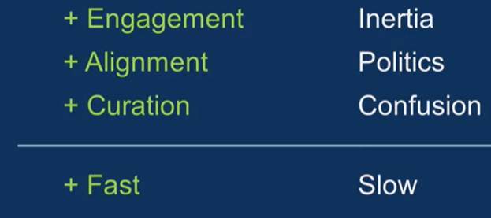

“Design's ability to deliver engagement and alignment and curation greatly enhances speed by removing the friction and the drag created by trying to unite people with different views of the world around a new idea. By drilling down to core insights and building a shared mind map of the current state, and then translating that into design criteria. The debates so common over new ideas tend to just go away. Because the question becomes whether or not the idea meets the criteria with sufficient rigor to be moved into experimentation. And that is a far more straight forward and fact based discussion than the kind we get when people evaluate a new idea from their own individual perspectives without a shared view grounded in stakeholders needs and desires.

And there is just one more opportunity I want to talk about that I think design brings. It is perhaps the fuzziest of all of them, but that is design's comfort with emptiness. With leaving space in the emergence of a solution, so that many can contribute to it.”

“And yet leaving things unfinished is one of the hardest things for a manager to do but also one of the most important.”🡪 need to find out more about what she meant by this

Here:

“In organizations, employees want to be invited to be part of works in progress, to feel the sense of discovery as they unfold. Why do we love game shows and sporting events and even mystifyingly, reality television? Because we don't know the outcome. Design thinking builds these possibilities into every step of the process. If only we can reduce our own discomfort and anxiety enough to allow the intrigue of discovering to take over. You know it's a wonderful paradox, that same ambiguity that makes us so anxious and uncomfortable, it turns out, also has the potential to unleash a level of energy we rarely experience when presented with a finished product.”